Exercise 7: Financial Forecasting
Scenario: You are developing a financial forecasting tool that predicts future values based on past data.
1. Explain the concept of recursion and how it can simplify certain problems.
Recursion is a problem-solving technique in which a function calls itself repeatedly until a specified condition is met. Instead of solving a problem all at once, recursion breaks it into smaller and simpler subproblems.

A recursive function generally contains two important parts:
- Base Case - The base case is the stopping condition of the recursion. It prevents the function from calling itself indefinitely and avoids infinite recursion.
- Recursive Case - The recursive case defines how the function calls itself with a smaller or simpler input, gradually moving towards the base case.
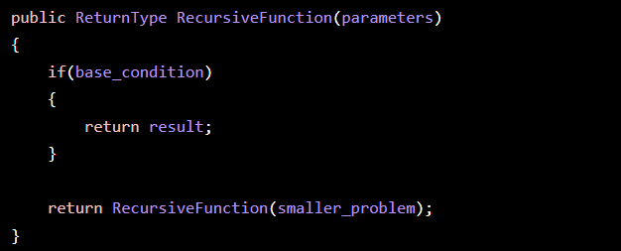

Recursion is useful when a problem can naturally be divided into smaller versions of the same problem. It often produces cleaner and more readable code compared to iterative approaches.
Advantages:
- Simplifies complex problems and easier-to-understand code.
- Useful for mathematical calculations, tree traversal, searching, and forecasting.
Disadvantages:
- Uses additional memory due to function call stacks and can be slower than iterative solutions for large inputs.

2. Implementation: Program.cs
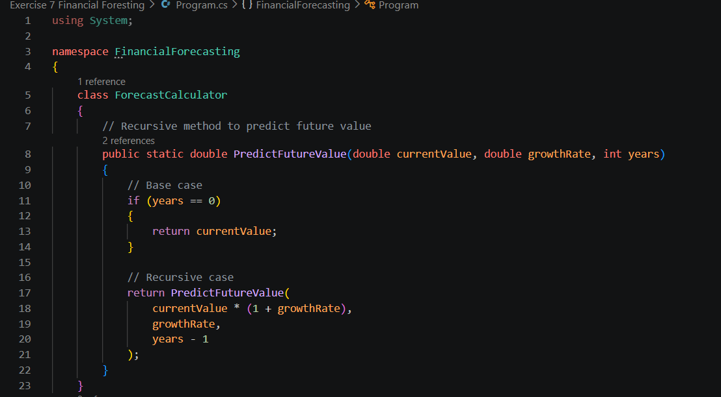
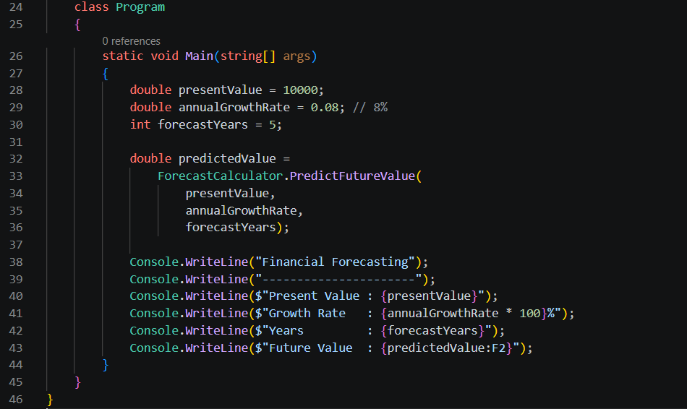

Output:
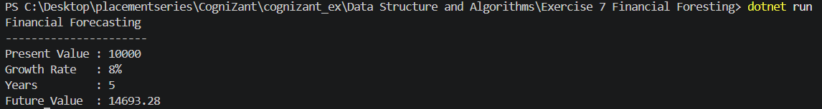

3. Explanation of the Algorithm
The recursive method:
PredictFutureValue(currentValue, growthRate, years)
works as follows:
For:
Current Value = 10000
Growth Rate = 8%
Years = 5
Calculation:
Year 1 = 10000 × 1.08 = 10800
Year 2 = 10800 × 1.08 = 11664
Year 3 = 11664 × 1.08 = 12597.12
Year 4 = 12597.12 × 1.08 = 13604.89
Year 5 = 13604.89 × 1.08 = 14693.28
The recursion continues until the number of years becomes 0.

4. Time Complexity Analysis
Recursive Solution
Each recursive call decreases the number of years by 1.
Therefore: T(n) = T(n-1) + O(1)
Time Complexity: O(n)
where n = number of years.
Space Complexity : O(n)
Because each recursive call is stored on the call stack.

5. Optimization
The recursive solution is simple but uses extra stack memory.
Optimized Iterative Approach
Instead of recursion:
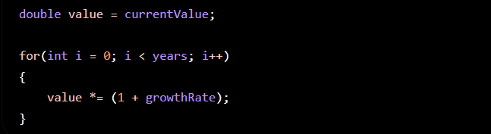
Benefits:
- No recursive call overhead
- Constant extra memory
Complexities:
Time Complexity : O(n)
Space Complexity : O(1)

Conclusion
- Recursion makes the forecasting logic easy to understand.
- Recursive time complexity is O(n).
- Recursive space complexity is O(n) due to the call stack.
- An iterative solution is more memory-efficient and preferred for large forecasting periods.

